**Course Specialist Year 12 Test Four 2022**

Student name: ________________ Teacher name: ________________

**Task type: Response**

**Time allowed for this task: _____40______ mins**

**Number of questions: _____6______**

**Materials required:** Upto 3Calculators with CAS capability (to be provided by the student)

Standard items: Pens (blue/black preferred), pencils (including coloured), sharpener, correction fluid/tape, eraser, ruler, highlighters

Special items: Drawing instruments, templates, notes on one unfolded sheet of   
A4 paper, and up to three calculators approved for use in the WACE examinations

**Marks available: __40____ marks**

**Task weighting: _10___%**

**Formula sheet provided: Yes**

**Note: All part questions worth more than 2 marks require working to obtain full marks.**

Q1 (5 marks)

Determine the volume of the solid formed by rotating the area enclosed between  about the y axis, as shown below.

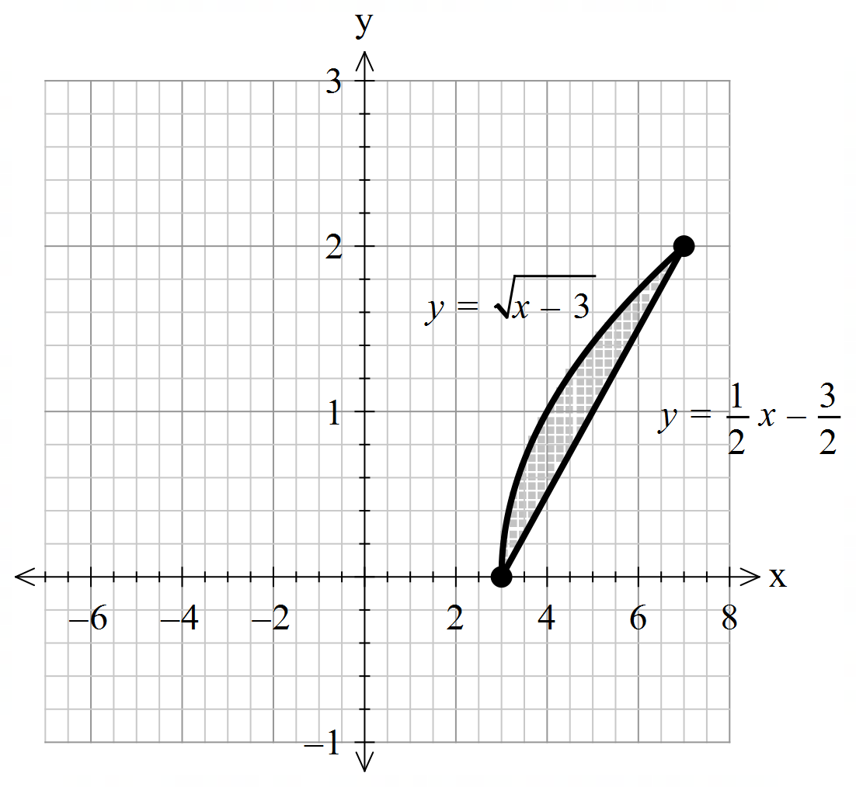

|  |
| --- |
| **Solution** |
|  |
| **Specific behaviours** |
| 🗸 uses correct integral type  🗸 determines x as the subject for each graph  🗸 sets up integrals for both functions with limits  🗸 uses subtraction after squaring  🗸states approx. volume of solid |

Q2 (5, 3 & 2= 10 marks)

1. By using integration and partial fractions, show how to derive  from the differential equation () and  is a constant

|  |
| --- |
| **Solution** |
|  |
| **Specific behaviours** |
| 🗸 explains limit of N and sign of a-bN  🗸 separates dN & dt and integrates  🗸 uses partial fractions  🗸 uses logs and obtains expression of N in terms of t  🗸shows derivation of final rule |

Q2 continued

1. Let  equal the number of kangaroos living in a habitat after  years and  .If initially there are  kangaroos, determine the number in 10 years time.

|  |
| --- |
| **Solution** |
|  |
| **Specific behaviours** |
| 🗸 solves for constant  🗸 subs t=10 into correct expression  🗸 states population (accept decimal) |

1. Determine the size of the population at the maximum growth rate.

|  |
| --- |
| **Solution** |
|  |
| **Specific behaviours** |
| 🗸 uses half of maximum  🗸 States population |

Q3 (3, 2 & 3 = 8 marks)

1. Sketch the slope field on the axes below for 

|  |
| --- |
| **Solution** |
|  |
| **Specific behaviours** |
| 🗸 left side near zero gradients  🗸 45 degrees on y axis i.e 1  🗸 right side approaches vertical lines, i.e infinite |

1. Show the solution curve on the axes above that passes through point (2,2).

|  |
| --- |
| **Solution** |
|  |
| **Specific behaviours** |
| 🗸 follows contours  🗸 passes through (2,2) |

1. Determine in cartesian form the solution curve for b above **without using a classpad**.

Hint – use logarithmic differentiation. Show all working.

|  |
| --- |
| **Solution** |
|  |
| **Specific behaviours** |
| 🗸 uses log diff to diff exponential  🗸 uses integration  🗸 solves for exact constant  **Note max 1 out of 3 if log diff not shown** |

Q4 (5 marks)

Determine expressions in terms of  only for  in terms of  using the following equation 

|  |
| --- |
| **Solution** |
|  |
| **Specific behaviours** |
| 🗸 uses product rule on both sides for first derivative  🗸 uses implicit diff in terms of x  🗸 uses product/quotient rule for second drivative  🗸 obtains an expression with second derivative  🗸makes second derivative subject in terms of x,y and first derivative |

Q5 (3 & 3 = 6 marks)

Consider a particle that is moving with SHM such that  with a maximum speed of 12 m/s.

1. Determine the exact speed when the particle is half of an amplitude from the origin.

|  |
| --- |
| **Solution** |
|  |
| **Specific behaviours** |
| 🗸 determines n & A  🗸 uses correct formula  🗸 states exact speed |

1. Determine the percentage of the time that the particle is more than half an amplitude from the centre.

|  |
| --- |
| **Solution** |
| Let |
| **Specific behaviours** |
| 🗸 determines a model for displacement and period  🗸 solves for times at half an amplitude in one cycle/(half cycle)  🗸 determines percentage of time |

Q6 (4 & 2 = 6 marks)

The motion of a bullet through a wall is modelled by the equation  where  is its acceleration and  its velocity  seconds after impact. Initially the speed is 300 and is at the origin (metres)

1. Determine  in terms of .

|  |
| --- |
| **Solution** |
|  |
| **Specific behaviours** |
| 🗸 uses dv & dx and separates variables v & x  🗸Integrates both sides  🗸 changes variable to integrate dv  🗸 solves for exact constant |

Q6 continued-

1. Determine how far the bullet penetrates the wall before coming to rest to the nearest mm.

|  |
| --- |
| **Solution** |
|  |
| **Specific behaviours** |
| 🗸 subs v=0  🗸 rounds to nearest mm |